

Project Documentation

FSMA PROJECT



[Date]

[Company name]

[Company address]

# Table of Contents

**Table of Contents** **2**

**User Stories** **3**

**Prioritization Method** **4**

**Burndown Charts** **5**

Weekly 5

Sprint 1 5

Sprint 2 6

Sprint 3 6

Sprint 4 7

Summary 7

**Weekly Sprint Documentation** **8**

Sprint Meetings 8

Sprint 1 8

Sprint 2 8

Sprint 3 8

Sprint 4 9

Trello Board Screenshots 9

Sprint 1 9

Sprint 2 10

Sprint 3 11

Sprint 4 12

# Login Credentials

Username: admin

Password: admin

# User Stories

* As a coach, I want to be able to see the statistics of each player, so I can better understand their strengths.
* As a coach, I want to be able to record the results of a match, so it can later be analyzed.
* As a coach, I want to know which team my team has played against.
* As a player, I want to be able to join a team, so i can participate in leagues
* As a player, I want to know how many goals I scored.
* As a player, I want to know how many assists I have.
* As a player, I want to know how many saves I have.
* As a player, I want to know my stats against different teams.
* As an organizer, I want to know who the mvp(most valuable player) is.
* As a user (person with interest), I want to see information about the league.
* As an organizer, I want to know which teams have the most goals

# Prioritization Method

Each week our prioritization method consisted of selecting the tasks that had the most dependencies, in the first week this mostly included the database and initial user stories as all other tasks relied on these. The second sprint was creating the models and controllers and the third testing them, and so on. We followed this method every sprint and had no problems with it, it enabled us to find the tasks our project depended on that sprint and prevented the project from being held up by any tasks.

# Burndown Charts

## Weekly

### Sprint 1

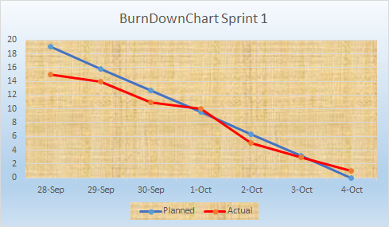

### Sprint 2

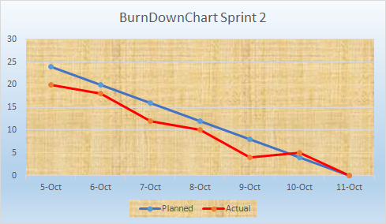

### Sprint 3

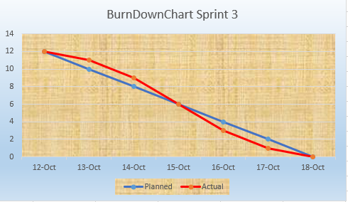

### Sprint 4

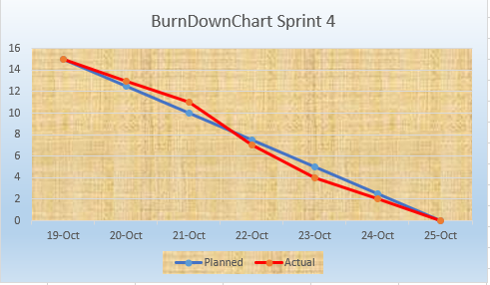

## Summary

## 

# Weekly Sprint Documentation

## Sprint Meetings

### Sprint 1

Sprint 1 Stand Up Meeting

Project Manager: Alen

Start: 3:17pm

End: 3:28pm

Duration:11 minutes

Review:

Discussed how first week went

Divided tasks for sprint 2

To-do:

Problem with database - Assigned to Daniel

Unit test wasn't completed _ Moved to sprint 2

No errors show on login page - Moved to sprint 2

Retrospective:

We discovered that the current database schema wouldn’t enable the user stories we intended to have and planned to change it in the next sprint.

### Sprint 2

Sprint 2 Stand Up Meeting

Project Manager: Qiang

Start: 4:20pm

End: 4:35pm

Duration:15 minutes

Review:

Talked about changes made to database

Discussed new ERD and database model

Assigned tasks for Sprint 3

To-do

Update ERD

Fix database

Retrospective:

No changes were required this sprint

### Sprint 3

Sprint 3 Stand Up Meeting

Project Manager: Dan

Start: 3:31pm

End: 3:37pm

Duration:6 minutes

Review:

Fixed database issue

Need more Whitebox tests

To-do:

Update ERD

Carry over leftover tasks to sprint 4

Retrospective:

No changes were required this sprint

### Sprint 4

Sprint 4 Stand Up Meeting

Project Manager: Alen

Start: 3:00pm

End: 3:13pm

Duration:7 minutes

Review:

Discussed what changes to be done to the UI

Reviewed created tests

To-do:

Create better UI

Retrospective:

We decided that our UI was not very suited to our management app and decided to change it next sprint

## Trello Board Screenshots

### Sprint 1

Sprint 1 Start board was not screenshotted

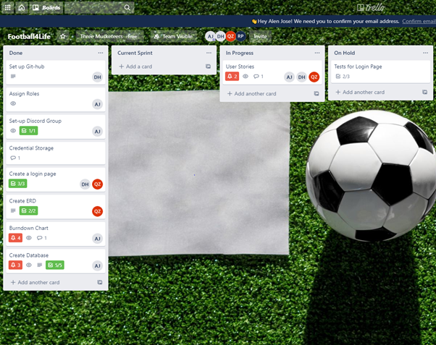

*Figure 1.1: Sprint 1 Trello Board End*

### Sprint 2

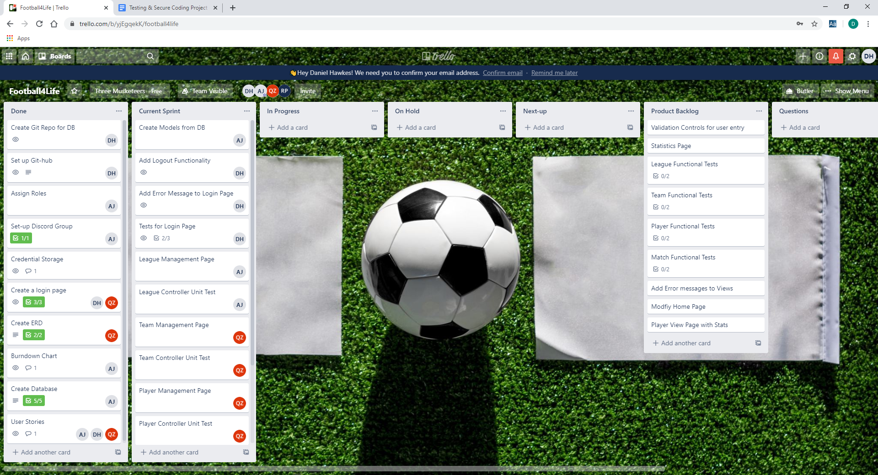

*Figure 1.2 Sprint 2 Trello Board Start*

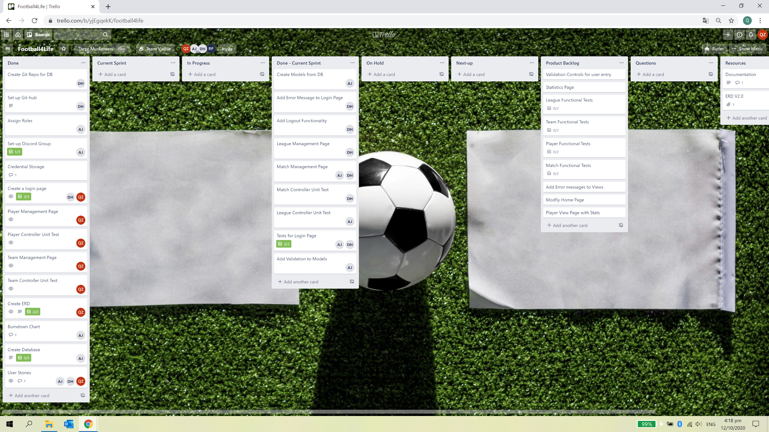

*Figure 1.3 Sprint 2 Trello Board End*

### Sprint 3

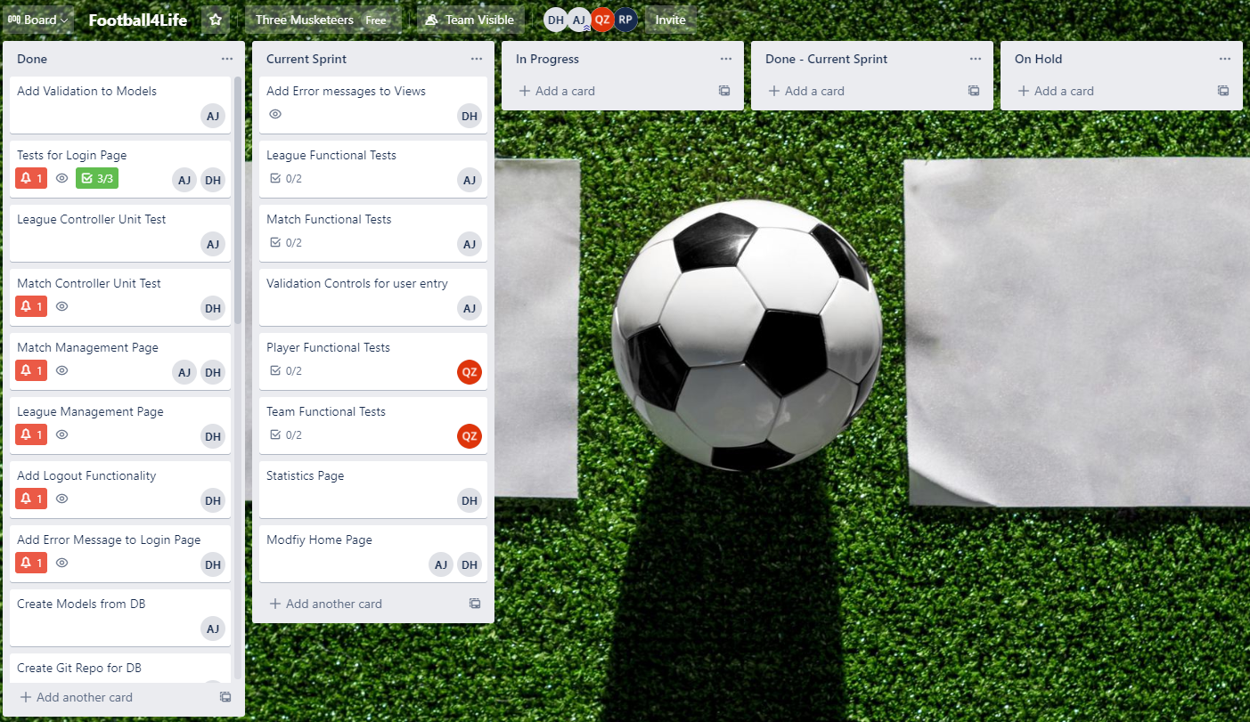

*Figure 1.4 Sprint 3 Trello Board Start*

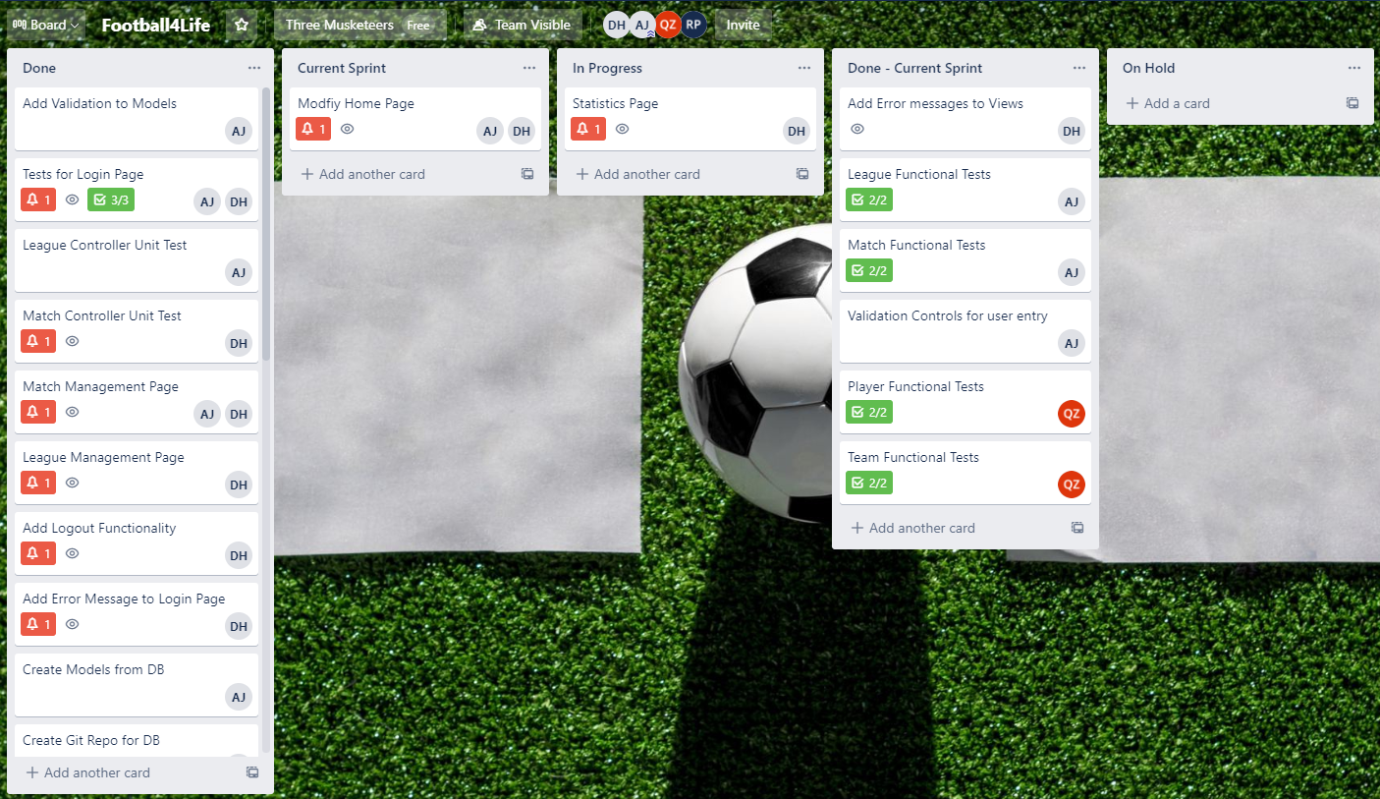

*Figure 1.5 Sprint 3 Trello Board End*

### Sprint 4

### 

*Figure 1.6 Sprint 4 Trello Board Start*

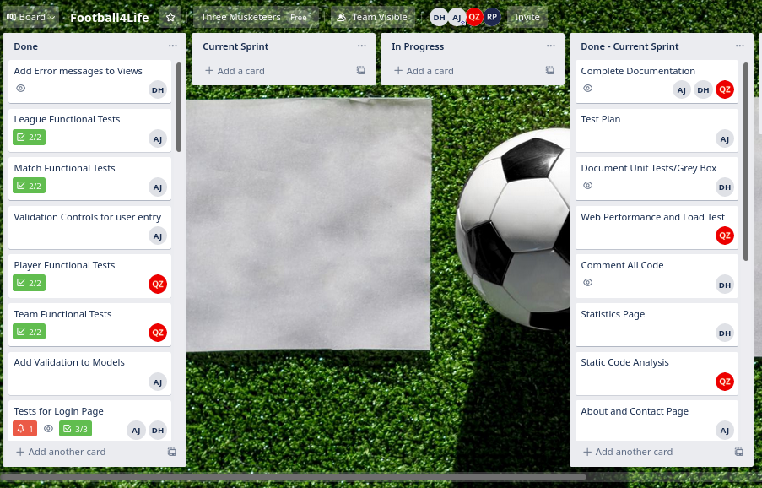

*Figure 1.7 Sprint 4 Trello Board End*

# Final ERD

